Experiment 1
Installation of Xampp

1) Download Xampp using wget command
wget https://downloadsapachefriends.global.ssl.fastly.net/xampp-files/7.2.1/xampp-linux-x64-7.2.1-0-installer.run?from_af=true
2) The Xampp file will be downloaded to the Downloads Folder. Open the Terminal. Type the following command in terminal to open file location
cd ~/Downloads
3) Run the following command to make it executable
chmod +x xampp-linux-x64-7.2.1-0-installer.run
4) To Install Xampp , Run the below command in terminal
./xampp-linux-x64-7.2.1-0-installer.run
5) After Few seconds a Pop-up Window will open . Install the xampp by clicking Next & Finish buttons when required. Once installaition is done .It will be installed in /opt/lampp directory.
6) Now you can start Xampp services using the following command.
/opt/lampp/lampp start
7) To Stop the service using the following command
/opt/lampp/lampp stop
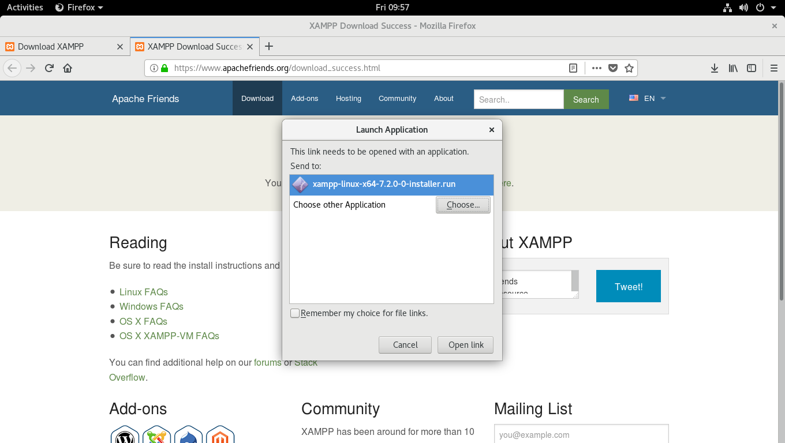
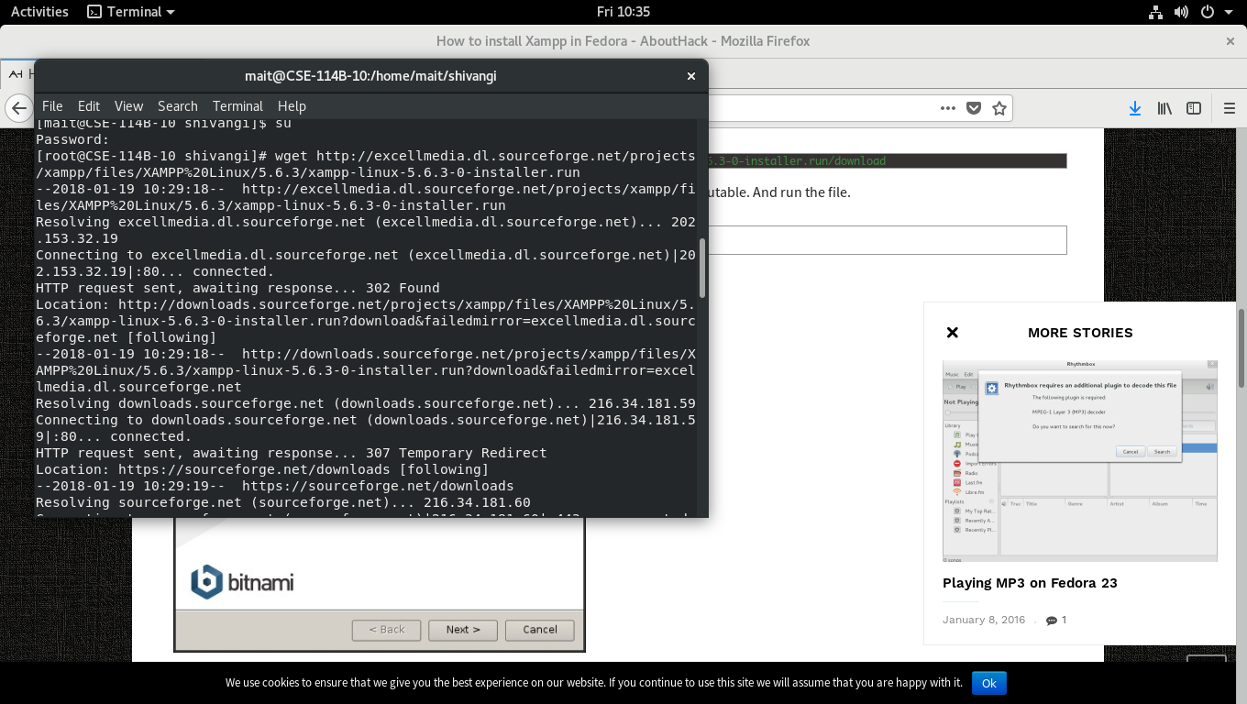
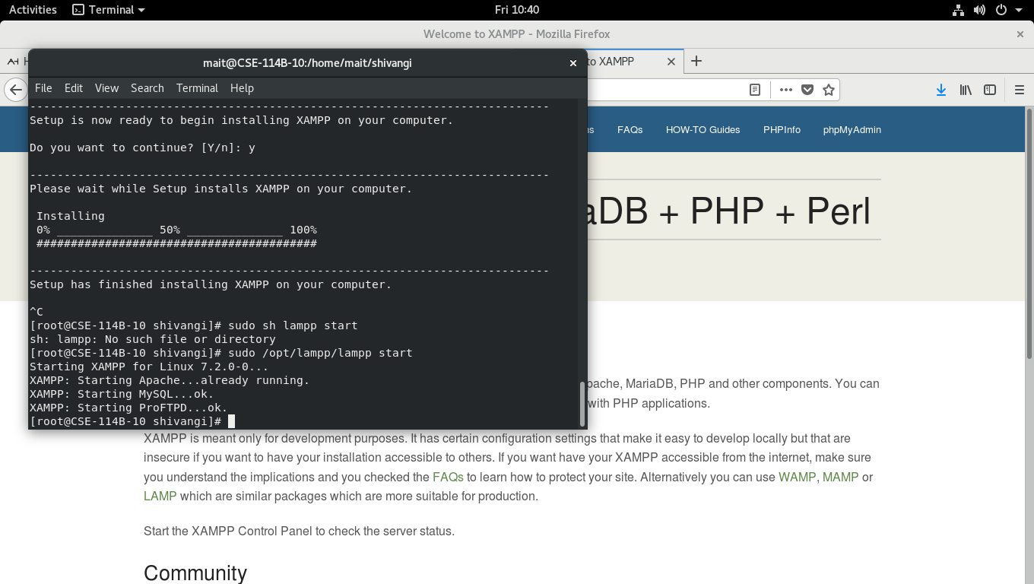

EXPERIMENT 2
AIM: To make a static page for website using HTML
About:
Hypertext Markup Language (HTML) is the standard markup language for creating web pages and web applications. Web browsers receive HTML documents from a web server or from local storage and render the documents into multimedia web pages. HTML describes the structure of a web page semantically and originally included cues for the appearance of the document.

HTML elements are the building blocks of HTML pages. With HTML constructs, images and other objects such as interactive forms may be embedded into the rendered page. HTML provides a means to create structured documents by denoting structural semantics for text such as headings, paragraphs, lists, links, quotes and other items. HTML elements are delineated by tags, written using angle brackets. Tags such as <img /> and <input /> directly introduce content into the page. Other tags such as <p>...</p> surround and provide information about document text and may include other tags as sub-elements. Browsers do not display the HTML tags, but use them to interpret the content of the page.

HTML can embed programs written in a scripting language such as JavaScript which affects the behaviour and content of web pages. Inclusion of CSS defines the look and layout of content.

Source Code:

<!DOCTYPE HTML>
<html>
<head>
<title>PopCornTime</title>
<meta charset="utf-8" />
</head>
<body class="is-preload">
<a class="logo" href="index.html">PopCornTime</a>
<nav>
<a href="#menu">Menu</a>
</nav>
<!-- Main -->
<section id="main">
<div class="inner">
<h1>PopCornTime</h1>
<p>A responsive movie review website
designed by Shivangi Singla and released under the Web Engineering License.</p>
</div>
</section>
<div class="inner">
<div class="content">
<section>
<h2>PopCornTime</h2>
<p>PopCornTime, the world's most popular and authoritative source for movie, TV, and celebrity content.<br> Get read critic and user reviews.<br> Explore popular Hollywood and Indian movies and TV shows, entertainment news, and the latest awards and events.<br> Track what you want to watch on your Watchlist, and rate movies and TV shows you've seen.
</p>
</section>
<section>
<h4>Company</h4>
</section>
<section>
<h4>Contact Us</h4>
</section>
</div>
</div>
</body>
</html>

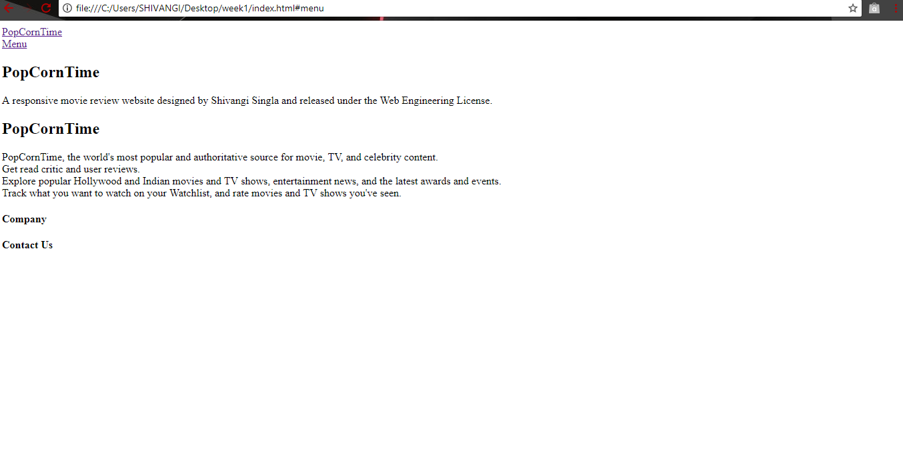

EXPERIMENT 3
AIM: To improve styling of webpage using CSS
About:

Cascading Style Sheets (CSS) is a style sheet language used for describing the presentation of a document written in a markup language. Although most often used to set the visual style of web pages and user interfaces written in HTML and XHTML, the language can be applied to any XML document, including plain XML, SVG and XUL, and is applicable to rendering in speech, or on other media. Along with HTML and JavaScript, CSS is a cornerstone technology used by most websites to create visually engaging webpages, user interfaces for web applications, and user interfaces for many mobile applications.

CSS is designed primarily to enable the separation of presentation and content, including aspects such as the layout, colors, and fonts. This separation can improve content accessibility, provide more flexibility and control in the specification of presentation characteristics, enable multiple HTML pages to share formatting by specifying the relevant CSS in a separate .css file, and reduce complexity and repetition in the structural content.

CSS can be added to a web page in three ways:
- Embedded CSS: We can put your CSS rules into an HTML document using the <style> element. This tag is placed inside <head>...</head> tags. Rules defined using this syntax will be applied to all the elements available in the document.

<style type = "text/css" media = "all">
body {
background-color: linen;
}
h1 {
color: maroon;
margin-left: 40px;
}
</style>

- Inline CSS: We can use style attribute of any HTML element to define style rules. These rules will be applied to that element only.

<h1 style = "color:#36C;"> This is inline CSS </h1>

- External CSS: The <link> element can be used to include an external stylesheet file in your HTML document. An external style sheet is a separate text file with .css extension. You define all the Style rules within this text file and then you can include this file in any HTML document using <link> element.

<head>
<link type = "text/css" href = "mystyle.css" media = " all" />
</head>

h1, h2, h3 {
color: #36C;
font-weight: normal;
letter-spacing: .4em;
margin-bottom: 1em;
text-transform: lowercase;
}

Source Code:

index.html:

<!DOCTYPE HTML>
<html>
<head>
<title>PopCornTime</title>
<meta charset="utf-8" />
<link rel="stylesheet" href="main1.css" />
</head>
<body class="is-preload">
<!-- Header -->
<header id="header">
<a class="logo" href="index.html">PopCornTime</a>
<nav>
<a href="#menu">Menu</a>
</nav>
</header>
<!-- Main -->
<section id="banner">
<div class="inner">
<h1>PopCornTime</h1>
<p>A responsive movie review website
designed by Shivangi Singla and released under the Web Engineering License.</p>
</div>
</section>
<!-- Footer -->
<footer id="footer">
<div class="inner">
<div class="content">
<section>
<h2>PopCornTime</h2>
<p>PopCornTime, the world's most popular and authoritative source for movie, TV, and celebrity content.<br> Read critic and user reviews.<br> Explore popular Hollywood and Indian movies and TV shows, entertainment news, and the latest awards and events.<br> Track what you want to watch on your Watchlist, and rate movies and TV shows you've seen.
</p>
</section>
<section>
<h4>Company</h4>
</section>
<section>
<h4>Contact Us</h4>
</section>
</div>
</div>
</footer>
</body>
</html>

css:

@import url(font-awesome.min.css);
@import url("https://fonts.googleapis.com/css?family=Raleway:200,300,400,500,600");
/* Basic */
@-ms-viewport {
width: device-width; }
body {
-ms-overflow-style: scrollbar; }
@media screen and (max-width: 480px) {
html, body {
min-width: 320px; } }
html {
box-sizing: border-box; }
*, *:before, *:after {
box-sizing: inherit; }
body {
background: #000000; }
body.is-preload *, body.is-preload *:before, body.is-preload *:after {
}
html, body, div, span, applet, object,
iframe, h1, h2, h3, h4, h5, h6, p, a, img, ins, b,
u, i, center, dl, dt, dd, ol, ul, li{
margin: 0;
padding: 0;
border: 0;
font-size: 100%;
font: inherit;
vertical-align: baseline; }
body {
line-height: 1; }
/* Typography */
html {
font-size: 14pt; }
@media screen and (max-width: 480px) {
html {
font-size: 11pt; } }
body {
background-color: #000000;
color: #444444; }
body, input, select, textarea {
font-family: "Raleway", Arial, Helvetica, sans-serif;
font-weight: 400;
font-size: 1rem;
line-height: 1.65; }
header.special {
text-align: center;
margin-bottom: 4rem; }
header.special p {
max-width: 80%;
margin-left: auto;
margin-right: auto; }
h1, h2, h3, h4, h5, h6 {
font-weight: 300;
line-height: 1.5;
text-transform: uppercase;
margin: 0 0 1.5rem 0; }
h1 a, h2 a, h3 a, h4 a, h5 a, h6 a {
color: inherit;
text-decoration: none; }
h1 {
font-size: 3rem;
line-height: 1.2; }
h3 {
font-size: 1.25rem; }
/* Inner */
.inner {
margin: 0 auto;
width: 75rem;
max-width: calc(100% - 6rem); }
label {
display: block;
font-size: 1rem;
font-weight: 600;
margin: 0 0 1rem 0; }
select option {
color: #444444;
background-color: #ffffff; }
/* Banner */
#banner {
background-color: #000000;
color: #ffffff;
background-position: center;
background-repeat: no-repeat;
text-align: center;
width: 100%; }
#banner input, #banner select, #banner textarea {
color: #ffffff; }
#banner a {
color: #ce1b28; }
#banner strong, #banner b {
color: #ffffff; }
#banner h1, #banner h2, #banner h3, #banner h4, #banner h5, #banner h6 {
color: #ffffff; }
/* Footer */
#footer {
background-color: #000000;
color: #01234f;
padding: 8rem 0 6rem 0 ; }
#footer input, #footer select, #footer textarea {
color: #ffffff; }
#footer a {
color: #ce1b28; }
#footer strong, #footer b {
color: #ffffff; }
#footer h1, #footer h2, #footer h3, #footer h4, #footer h5, #footer h6 {
color: #ffffff; }
#footer blockquote {
border-left-color: rgba(255, 255, 255, 0.25); }
#footer code {
background: rgba(255, 255, 255, 0.075);
border-color: rgba(255, 255, 255, 0.25); }
#footer hr {
border-bottom-color: rgba(255, 255, 255, 0.25); }
#footer table.alt tbody tr td {
border-color: rgba(255, 255, 255, 0.25); }
#footer .highlights .content {
background: #111111;
box-shadow: 0px 0px 4px 1px rgba(255, 255, 255, 0.025); }
#footer .content {
display: -moz-flex;
display: -webkit-flex;
display: -ms-flex;
display: flex; }
#footer .content section {
width: 25%; }
#footer .content section:first-child {
width: 50%;
padding-right: 4rem; }
#footer .content section:last-child {
padding-left: 4rem; }
/* Header */
body {
padding-top: 3.25rem; }
body:before {
content: ' ';
background-size: cover;
background-repeat: no-repeat;
background-attachment: fixed;
display: block;
position: fixed;
left: 0;
top: 0;
width: 100%;
height: 100%;
z-index: -1;
opacity: 0.05; }
#header {
-moz-align-items: center;
-webkit-align-items: center;
-ms-align-items: center;
align-items: center;
display: -moz-flex;
display: -webkit-flex;
display: -ms-flex;
display: flex;
-moz-justify-content: space-between;
-webkit-justify-content: space-between;
-ms-justify-content: space-between;
justify-content: space-between;
background: #000000;
color: #ce1b28;
cursor: default;
height: 3.25rem;
left: 0;
line-height: 3.25rem;
position: fixed;
top: 0;
width: 100%;
z-index: 10001; }
#header > .logo {
color: #ce1b28;
font-size: 1rem;
font-weight: 600;
height: inherit;
line-height: inherit;
padding: 0 1.25rem;
text-decoration: none; }
#header > nav > a {
color: inherit;
display: inline-block;
padding: 0 0.75rem;
text-decoration: none; }
#header > nav > a:hover {
color: #ffffff; }
#header > nav > a[href="#menu"] {
text-decoration: none;
-webkit-tap-highlight-color: rgba(0, 0, 0, 0); }
#header > nav > a[href="#menu"]:before {
-moz-osx-font-smoothing: grayscale;
-webkit-font-smoothing: antialiased;
font-family: FontAwesome;
font-style: normal;
font-weight: normal;
text-transform: none !important; }
#header > nav > a[href="#menu"]:before {
content: '\f0c9';
margin: 0 0.5rem 0 0; }
#header > nav > a + a[href="#menu"]:last-child {
border-left: solid 1px rgba(255, 255, 255, 0.25);
margin-left: 0.5rem;
padding-left: 1.25rem; }
#header > nav > a:last-child {
padding-right: 1.25rem; }
/* Heading */
#heading {
-ms-flex-align: center;
-ms-flex-pack: center;
background-color: #000000;
color: rgba(255, 255, 255, 0.5);
-moz-align-items: center;
-webkit-align-items: center;
-ms-align-items: center;
align-items: center;
-moz-justify-content: center;
-webkit-justify-content: center;
-ms-justify-content: center;
justify-content: center;
background-image: linear-gradient(rgba(17, 17, 17, 0.25), rgba(17, 17, 17, 0.25)), url("../../images/banner.jpg");
background-position: center;
background-repeat: no-repeat;
background-size: cover;
border-top: 0;
display: -ms-flexbox;
height: 15rem !important;
min-height: 15rem;
overflow: hidden;
position: relative;
text-align: center;
width: 100%; }
#heading input, #heading select, #heading textarea {
color: #ffffff; }
#heading a {
color: #ce1b28; }
#heading strong, #heading b {
color: #ffffff; }
#heading h1, #heading h2, #heading h3, #heading h4, #heading h5, #heading h6 {
color: #ffffff; }
#heading blockquote {
border-left-color: rgba(255, 255, 255, 0.25); }
#heading code {
background: rgba(255, 255, 255, 0.075);
border-color: rgba(255, 255, 255, 0.25); }
#heading hr {
border-bottom-color: rgba(255, 255, 255, 0.25); }
#heading ul.alt li {
border-top-color: rgba(255, 255, 255, 0.25); }
#heading table tbody tr {
border-color: rgba(255, 255, 255, 0.25); }
#heading table tbody tr:nth-child(2n + 1) {
background-color: rgba(255, 255, 255, 0.075); }
#heading table th {
color: #ffffff; }
#heading table thead {
border-bottom-color: rgba(255, 255, 255, 0.25); }
#heading table tfoot {
border-top-color: rgba(255, 255, 255, 0.25); }
#heading table.alt tbody tr td {
border-color: rgba(255, 255, 255, 0.25); }
#heading .highlights .content {
background: #111111;
box-shadow: 0px 0px 4px 1px rgba(255, 255, 255, 0.025); }
#heading:before {
background: linear-gradient(135deg, #ce1b28 0%, #111111 74%);
content: ' ';
display: block;
height: 100%;
left: 0;
opacity: 0.6;
position: absolute;
top: 0;
width: 100%;
z-index: 1; }
#heading h1 {
margin-bottom: 0;
position: relative;
z-index: 2; }
@media screen and (max-width: 980px) {
#heading {
padding: 2rem; } }

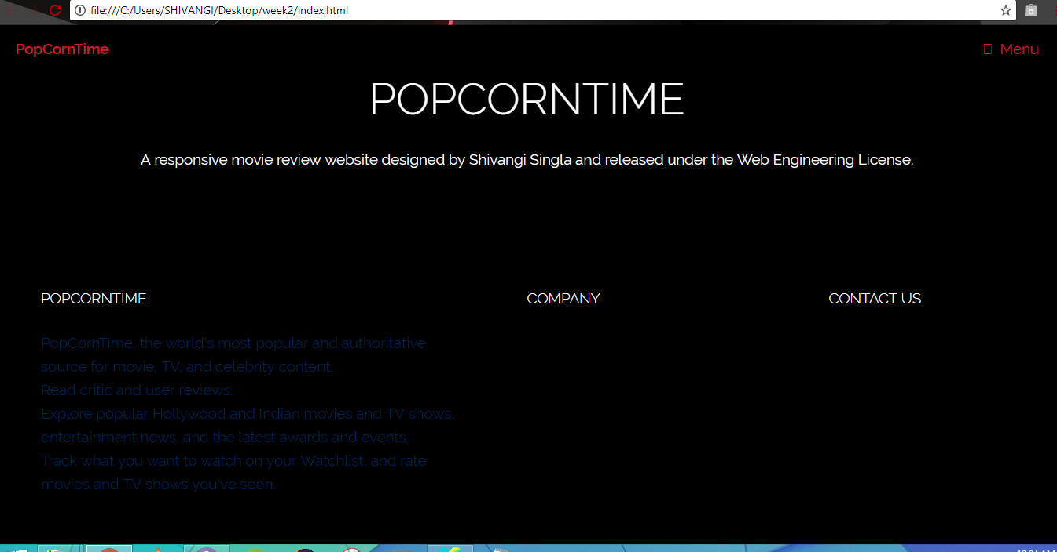

EXPERIMENT 4
AIM: To use <table>, <form>, <ol>, <ul> tags in a HTML webpage.
About:

HTML table:
An HTML table is defined with the <table> tag. Each table row is defined with the <tr> tag. A table header is defined with the <th> tag. By default, table headings are bold and centered. A table data/cell is defined with the <td> tag.

HTML form:
The HTML <form> tag is used for creating a form for user input. A form can contain textfields, checkboxes, radio-buttons and more. Forms are used to pass user-data to a specified URL.

HTML unordered list:
An unordered list starts with the <ul> tag. Each list item starts with the <li> tag. The list items will be marked with bullets (small black circles) by default.

HTML ordered list:
The <ol> tag defines an ordered list. An ordered list can be numerical or alphabetical. Use the <li> tag to define list items.

Source Code:

index:

<!DOCTYPE HTML>
<html>
<head>
<title>PopCornTime</title>
<meta charset="utf-8" />
<style type="text/css">
#menu { float:right; clear:right; padding-top:29px; padding-bottom:47px; }
#menu ul { list-style:none; }
#menu ul li { float:left; display:inline; padding-left:25px; }
#menu ul li a { font-size:14px; font-weight:bold; color:#ffffff; text-decoration:none; }
#menu ul li a.active,
#menu ul li a:hover { color:#ff361a; }
#sub-navigation { display:block; clear:right; border-top:1px dashed #666; border-bottom:1px dashed #666; padding:8px 0; }
#sub-navigation ul { list-style:none; }
#sub-navigation ul li { float:left; display:inline; padding-right:23px; }
#sub-navigation ul li a { font-size:14px; font-weight:bold; color:#ffffff; line-height:24px; text-decoration:none; }
#sub-navigation ul li a:hover { text-decoration:underline; }
#search { width:346px; margin:0 0 0 auto; }
#search label { float:left; display:inline; font-size:14px; font-weight:bold; color:#ffffff; line-height:24px; padding-right:6px; }
#search .search-field { width:238px; border: 1px solid #413e3e; background:#ffffff; color:#787878; padding:2px 0 2px 2px; }
#search .search-button { font-size:14px; font-weight:bold; border:0; background:none; color:#ffffff; cursor:pointer; }
</style>
<link rel="stylesheet" href="main1.css" />
</head>
<body class="is-preload">
<!-- Header -->
<header id="header">
<a class="logo" href="index.html">PopCornTime</a>
<nav>
<a href="#menu">Menu</a>
</nav>
</header>
<!-- Main -->
<div id="menu">
<ul>
<li><a class="active" href="#">HOME</a></li>
<li><a href="#">NEWS</a></li>
<li><a href="#">IN THEATERS</a></li>
<li><a href="#">COMING SOON</a></li>
<li><a href="#">CONTACT</a></li>
<li><a href="#">ADVERTISE</a></li>
</ul>
</div>
<div id="sub-navigation">
<ul>
<li><a href="#">SHOW ALL</a></li>
<li><a href="#">LATEST TRAILERS</a></li>
<li><a href="#">TOP RATED</a></li>
<li><a href="#">MOST COMMENTED</a></li>
</ul>
<div id="search">
<form action="home_submit" method="get" accept-charset="utf-8">
<label for="search-field">SEARCH</label>
<input type="text" name="search field" value="Enter search here" id="search-field" title="Enter search here" class="blink search-field" />
<input type="submit" value="GO!" class="search-button" />
</form>
</div>
</div>
<section id="banner">
<div class="inner">
<h1>PopCornTime</h1>
<p>A responsive movie review website
designed by Shivangi Singla and released under the Web Engineering License.</p>
</div>
<div class="signup1">
<form class="signup1-form validate-form">
<span class="signup1-form-title">
Signup
</span>
<div class="name-input" >
Name<br>
<input class="input100" type="text" name="name" placeholder="Enter your name">
</div>
<div class="email-input" >
Login ID<br>
<input class="input100" type="text" name="email" placeholder="Enter mobile number">
</div>
<div class="pswd-input" >
Password<br>
<input class="input100" type="password" name="pswd" placeholder="Enter password">
</div>
<div class="rpswd-input" >
Confirm Password<br>
<input class="input100" type="password" name="rpswd" placeholder="Re-enter password">
</div>
<div class="signup1-form-btn">
<button class="cancel-btn">
<span>
Cancel
</span>
</button>
<button class="next-btn">
<span>
Next
</span>
</button>
</div>
</form>
</div>
</section>
<!-- Footer -->
<footer id="footer">
<div class="inner">
<div class="content">
<section>
<h2>PopCornTime</h2>
<p>PopCornTime, the world's most popular and authoritative source for movie, TV, and celebrity content.<br> Read critic and user reviews.<br> Explore popular Hollywood and Indian movies and TV shows, entertainment news, and the latest awards and events.<br> Track what you want to watch on your Watchlist, and rate movies and TV shows you've seen.
</p>
</section>
<section>
<h4>Company</h4>
<ul class="alt">
<li><a href="#">About Us</a></li>
<li><a href="#">Copyright</a></li>
<li><a href="#">Privacy.</a></li>
</ul>
</section>
<section>
<h4>Contact Us</h4>
<ul class="plain">
<li><a href="#"><i class="icon fa-twitter">&nbsp;</i>Twitter</a></li>
<li><a href="#"><i class="icon fa-facebook">&nbsp;</i>Facebook</a></li>
</ul>
</section>
</div>
</div>
</footer>
<script src="assets/js/jquery.min.js"></script>
<script src="assets/js/browser.min.js"></script>
<script src="assets/js/breakpoints.min.js"></script>
<script src="assets/js/util.js"></script>
<script src="assets/js/main.js"></script>
</body>
</html>

css:

@import url(font-awesome.min.css);
@import url("https://fonts.googleapis.com/css?family=Raleway:200,300,400,500,600");
/* Basic */
@-ms-viewport {
width: device-width; }
body, signup1 {
-ms-overflow-style: scrollbar; }
article, aside, details, figcaption, figure,
footer, header, hgroup, menu, nav, section {
display: block; }
@media screen and (max-width: 480px) {
html, body {
min-width: 320px; } }
html {
box-sizing: border-box; }
*, *:before, *:after {
box-sizing: inherit; }
body, signup1 {
background: #000000; }
body.is-preload *, body.is-preload *:before, body.is-preload *:after {
}
html, body, div, span, applet, object,
iframe, h1, h2, h3, h4, h5, h6, p, a, img, ins, b,
u, i, center, dl, dt, dd, ol, ul, li, signup1{
margin: 0;
padding: 0;
border: 0;
font-size: 100%;
font: inherit;
vertical-align: baseline; }
body, signup1 {
line-height: 1; }
/* Typography */
html {
font-size: 14pt; }
@media screen and (max-width: 480px) {
html {
font-size: 11pt; } }
body, signup1 {
background-color: #000000;
color: #ce1b28;
padding: 15px;
text-align: center;
margin-bottom: 40rem;
font-family: Poppins-Bold;
font-size: 39px;
}
.signup1-form-title{
color: #ce1b28;
font-size:50px;}
.input{
background: transparent;
display: block;
justify-content: center;
text-align: justify;}
.signup1-form-btn{
padding-top:25px;
}
.cancel-btn,.next-btn{
color: #ce1b28;
margin: 10px;
padding:2px;}
.share{
margin:50px;
color:rgba(250, 100, 100, 100);}
body, input, select, textarea {
font-family: "Raleway", Arial, Helvetica, sans-serif;
font-weight: 400;
font-size: 1rem;
line-height: 1.65; }
header.special {
text-align: center;
margin-bottom: 4rem; }
header.special p {
max-width: 80%;
margin-left: auto;
margin-right: auto; }
h1, h2, h3, h4, h5, h6 {
font-weight: 300;
line-height: 1.5;
text-transform: uppercase;
margin: 0 0 1.5rem 0; }
h1 a, h2 a, h3 a, h4 a, h5 a, h6 a {
color: inherit;
text-decoration: none; }
h1 {
font-size: 3rem;
line-height: 1.2; }
h3 {
font-size: 1.25rem; }
/* Inner */
.inner {
margin: 0 auto;
width: 75rem;
max-width: calc(100% - 6rem); }
label {
display: block;
font-size: 1rem;
font-weight: 600;
margin: 0 0 1rem 0; }
select option {
color: #444444;
background-color: #ffffff; }
/* Banner */
#banner {
background-color: #000000;
color: #ffffff;
background-position: center;
background-repeat: no-repeat;
text-align: center;
width: 100%; }
#banner input, #banner select, #banner textarea {
color: #ffffff; }
#banner a {
color: #ce1b28; }
#banner strong, #banner b {
color: #ffffff; }
#banner h1, #banner h2, #banner h3, #banner h4, #banner h5, #banner h6 {
color: #ffffff; }
/* Footer */
#footer {
background-color: #000000;
color: #01234f;
padding: 8rem 0 6rem 0 ; }
#footer input, #footer select, #footer textarea {
color: #ffffff; }
#footer a {
color: #01234f; }
#footer strong, #footer b {
color: #ffffff; }
#footer h1, #footer h2, #footer h3, #footer h4, #footer h5, #footer h6 {
color: #ffffff; }
#footer blockquote {
border-left-color: rgba(255, 255, 255, 0.25); }
#footer code {
background: rgba(255, 255, 255, 0.075);
border-color: rgba(255, 255, 255, 0.25); }
#footer hr {
border-bottom-color: rgba(255, 255, 255, 0.25); }
#footer table.alt tbody tr td {
border-color: rgba(255, 255, 255, 0.25); }
#footer .highlights .content {
background: #111111;
box-shadow: 0px 0px 4px 1px rgba(255, 255, 255, 0.025); }
#footer .content {
display: -moz-flex;
display: -webkit-flex;
display: -ms-flex;
display: flex; }
#footer .content section {
width: 25%; }
#footer .content section:first-child {
width: 50%;
padding-right: 4rem; }
#footer .content section:last-child {
padding-left: 4rem; }
/* Header */
body {
padding-top: 3.25rem; }
body:before {
content: ' ';
background-size: cover;
background-repeat: no-repeat;
background-attachment: fixed;
display: block;
position: fixed;
left: 0;
top: 0;
width: 100%;
height: 100%;
z-index: -1;
opacity: 0.05; }
#header {
-moz-align-items: center;
-webkit-align-items: center;
-ms-align-items: center;
align-items: center;
display: -moz-flex;
display: -webkit-flex;
display: -ms-flex;
display: flex;
-moz-justify-content: space-between;
-webkit-justify-content: space-between;
-ms-justify-content: space-between;
justify-content: space-between;
background: #000000;
color: #ce1b28;
cursor: default;
height: 3.25rem;
left: 0;
line-height: 3.25rem;
position: fixed;
top: 0;
width: 100%;
z-index: 10001; }
#header > .logo {
color: #ce1b28;
font-size: 1rem;
font-weight: 600;
height: inherit;
line-height: inherit;
padding: 0 1.25rem;
text-decoration: none; }
#header > nav > a {
color: inherit;
display: inline-block;
padding: 0 0.75rem;
text-decoration: none; }
#header > nav > a:hover {
color: #ffffff; }
#header > nav > a[href="#menu"] {
text-decoration: none;
-webkit-tap-highlight-color: rgba(0, 0, 0, 0); }
#header > nav > a[href="#menu"]:before {
-moz-osx-font-smoothing: grayscale;
-webkit-font-smoothing: antialiased;
font-family: FontAwesome;
font-style: normal;
font-weight: normal;
text-transform: none !important; }
#header > nav > a[href="#menu"]:before {
content: '\f0c9';
margin: 0 0.5rem 0 0; }
#header > nav > a + a[href="#menu"]:last-child {
border-left: solid 1px rgba(255, 255, 255, 0.25);
margin-left: 0.5rem;
padding-left: 1.25rem; }
#header > nav > a:last-child {
padding-right: 1.25rem; }
/* Heading */
#heading {
-ms-flex-align: center;
-ms-flex-pack: center;
background-color: #000000;
color: #ffffff;
-moz-align-items: center;
-webkit-align-items: center;
-ms-align-items: center;
align-items: center;
-moz-justify-content: center;
-webkit-justify-content: center;
-ms-justify-content: center;
justify-content: center;
background-image: linear-gradient(rgba(17, 17, 17, 0.25), rgba(17, 17, 17, 0.25)), url("../../images/banner.jpg");
background-position: center;
background-repeat: no-repeat;
background-size: cover;
border-top: 0;
display: -ms-flexbox;
height: 15rem !important;
min-height: 15rem;
overflow: hidden;
position: relative;
text-align: center;
width: 100%; }
#heading input, #heading select, #heading textarea {
color: #ffffff; }
#heading a {
color: #ce1b28; }
#heading strong, #heading b {
color: #ffffff; }
#heading h1, #heading h2, #heading h3, #heading h4, #heading h5, #heading h6 {
color: #ffffff; }
#heading blockquote {
border-left-color: rgba(255, 255, 255, 0.25); }
#heading code {
background: rgba(255, 255, 255, 0.075);
border-color: rgba(255, 255, 255, 0.25); }
#heading hr {
border-bottom-color: rgba(255, 255, 255, 0.25); }
#heading ul.alt li {
border-top-color: rgba(255, 255, 255, 0.25); }
#heading table tbody tr {
border-color: rgba(255, 255, 255, 0.25); }
#heading table tbody tr:nth-child(2n + 1) {
background-color: rgba(255, 255, 255, 0.075); }
#heading table th {
color: #ffffff; }
#heading table thead {
border-bottom-color: rgba(255, 255, 255, 0.25); }
#heading table tfoot {
border-top-color: rgba(255, 255, 255, 0.25); }
#heading table.alt tbody tr td {
border-color: rgba(255, 255, 255, 0.25); }
#heading .highlights .content {
background: #111111;
box-shadow: 0px 0px 4px 1px rgba(255, 255, 255, 0.025); }
#heading:before {
background: linear-gradient(135deg, #ce1b28 0%, #111111 74%);
content: ' ';
display: block;
height: 100%;
left: 0;
opacity: 0.6;
position: absolute;
top: 0;
width: 100%;
z-index: 1; }
#heading h1 {
margin-bottom: 0;
position: relative;
z-index: 2; }
@media screen and (max-width: 980px) {
#heading {
padding: 2rem; } }
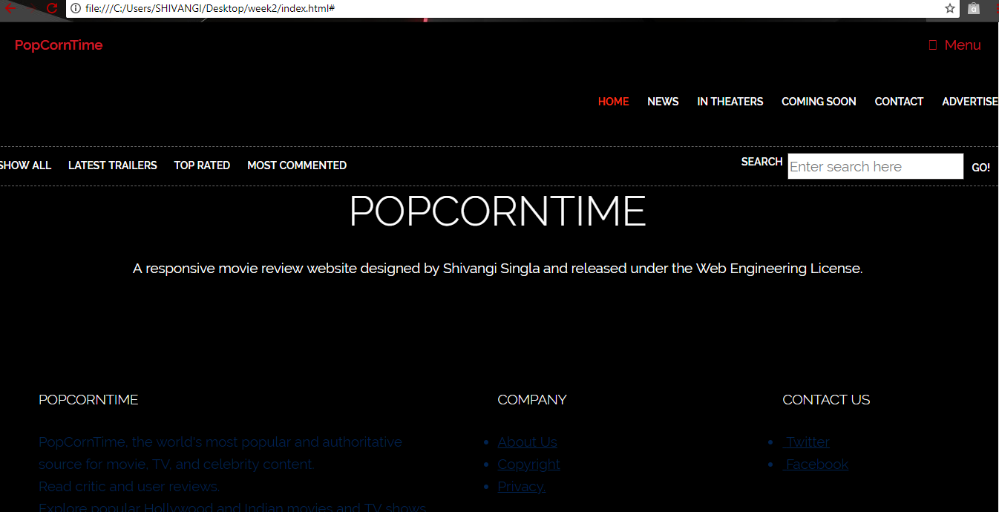

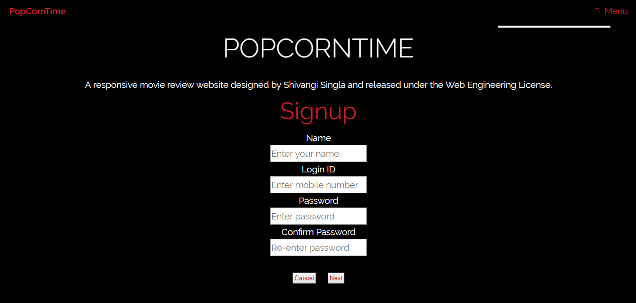

EXPERIMENT 5
AIM: To use Java Server Pages (JSP) to make backend of website. Use it to fetch data from a MySQL database and display that in a table.

About:
JSP
Java Server Pages (JSP) is a technology which is used to develop web pages by inserting Java code into the HTML pages by making special JSP tags. The JSP tags which allow java code to be included into it are <% ----java code----%>. It can consist of either HTML or XML (combination of both is also possible) with JSP actions and commands. It can be used as HTML page, which can be used in forms and registration pages with the dynamic content into it. Dynamic content includes some fields like dropdown, checkboxes, etc. whose value will be fetched from the database. This can also be used to access JavaBeans objects. We can share information across pages using request and response objects. JSP can be used for separation of the view layer with the business logic in the web application.

MySQL
MySQL runs on virtually all platforms, including Linux, UNIX, and Windows. Although it can be used in a wide range of applications, MySQL is most often associated with web-based applications and online publishing and is an important component of an open source enterprise stack called LAMP. LAMP is a Web development platform that uses Linux as the operating system, Apache as the Web server, MySQL as the relational database management system and PHP as the object-oriented scripting language. (Sometimes Perl or Python is used instead of PHP.)

Soucre Code:

index:

<!DOCTYPE HTML>
<%@ page import = "java.io.*,java.util.*, javax.servlet.*,java.text.*" %>
<html>
<head>
<title>PopCornTime</title>
<meta charset="utf-8" />
<style type="text/css">
#menu { float:right; clear:right; padding-top:29px; padding-bottom:47px; }
#menu ul { list-style:none; }
#menu ul li { float:left; display:inline; padding-left:25px; }
#menu ul li a { font-size:14px; font-weight:bold; color:#ffffff; text-decoration:none; }
#menu ul li a.active,
#menu ul li a:hover { color:#ff361a; }
#sub-navigation { display:block; clear:right; border-top:1px dashed #666; border-bottom:1px dashed #666; padding:8px 0; }
#sub-navigation ul { list-style:none; }
#sub-navigation ul li { float:left; display:inline; padding-right:23px; }
#sub-navigation ul li a { font-size:14px; font-weight:bold; color:#ffffff; line-height:24px; text-decoration:none; }
#sub-navigation ul li a:hover { text-decoration:underline; }
#search { width:346px; margin:0 0 0 auto; }
#search label { float:left; display:inline; font-size:14px; font-weight:bold; color:#ffffff; line-height:24px; padding-right:6px; }
#search .search-field { width:238px; border: 1px solid #413e3e; background:#ffffff; color:#787878; padding:2px 0 2px 2px; }
#search .search-button { font-size:14px; font-weight:bold; border:0; background:none; color:#ffffff; cursor:pointer; }
</style>
<link rel="stylesheet" href="main1.css" />
</head>
<body class="is-preload">
<!-- Header -->
<header id="header">
<a class="logo" href="index.html">PopCornTime</a>
<%
Date date = new Date();
SimpleDateFormat ft = new SimpleDateFormat ("hh:mm dd.MM.yyyy E");
out.print( "<h2 align = \"right\">" +ft.format(date)+"</h2>");
%>
<nav>
<a href="#menu">Menu</a>
</nav>
</header>
<!-- Main -->
<div id="menu">
<ul>
<li><a class="active" href="#">HOME</a></li>
<li><a href="#">NEWS</a></li>
<li><a href="#">IN THEATERS</a></li>
<li><a href="#">COMING SOON</a></li>
<li><a href="#">CONTACT</a></li>
<li><a href="#">ADVERTISE</a></li>
</ul>
</div>
<div id="sub-navigation">
<ul>
<li><a href="#">SHOW ALL</a></li>
<li><a href="#">LATEST TRAILERS</a></li>
<li><a href="#">TOP RATED</a></li>
<li><a href="#">MOST COMMENTED</a></li>
</ul>
<div id="search">
<form action="home_submit" method="get" accept-charset="utf-8">
<label for="search-field">SEARCH</label>
<input type="text" name="search field" value="Enter search here" id="search-field" title="Enter search here" class="blink search-field" />
<input type="submit" value="GO!" class="search-button" />
</form>
</div>
</div>
<section id="banner">
<div class="inner">
<h1>PopCornTime</h1>
<p>A responsive movie review website
designed by Shivangi Singla and released under the Web Engineering License.</p>
</div>
<div class="signup1">
<form class="signup1-form validate-form">
<span class="signup1-form-title">
Signup
</span>
<div class="name-input" >
Name<br>
<input class="input100" type="text" name="name" placeholder="Enter your name">
</div>
<div class="email-input" >
Login ID<br>
<input class="input100" type="text" name="email" placeholder="Enter mobile number">
</div>
<div class="pswd-input" >
Password<br>
<input class="input100" type="password" name="pswd" placeholder="Enter password">
</div>
<div class="rpswd-input" >
Confirm Password<br>
<input class="input100" type="password" name="rpswd" placeholder="Re-enter password">
</div>
<div class="signup1-form-btn">
<button class="cancel-btn">
<span>
Cancel
</span>
</button>
<button class="next-btn">
<span>
Next
</span>
</button>
</div>
</form>
</div>
</section>
<%
out.println("Your IP address is " + request.getRemoteAddr());
%>
<!-- Footer -->
<footer id="footer">
<div class="inner">
<div class="content">
<section>
<h2>PopCornTime</h2>
<p>PopCornTime, the world's most popular and authoritative source for movie, TV, and celebrity content.<br> Read critic and user reviews.<br> Explore popular Hollywood and Indian movies and TV shows, entertainment news, and the latest awards and events.<br> Track what you want to watch on your Watchlist, and rate movies and TV shows you've seen.
</p>
</section>
<section>
<h4>Company</h4>
<ul class="alt">
<li><a href="#">About Us</a></li>
<li><a href="#">Copyright</a></li>
<li><a href="#">Privacy.</a></li>
</ul>
</section>
<section>
<h4>Contact Us</h4>
<ul class="plain">
<li><a href="#"><i class="icon fa-twitter">&nbsp;</i>Twitter</a></li>
<li><a href="#"><i class="icon fa-facebook">&nbsp;</i>Facebook</a></li>
</ul>
</section>
</div>
</div>
</footer>
<script src="assets/js/jquery.min.js"></script>
<script src="assets/js/browser.min.js"></script>
<script src="assets/js/breakpoints.min.js"></script>
<script src="assets/js/util.js"></script>
<script src="assets/js/main.js"></script>
</body>
</html>

Sql:

<%@page import="java.sql.ResultSet"%>
<%@page import="java.sql.Statement"%>
<%@page import="java.sql.DriverManager"%>
<%@page import="java.sql.Connection"%>
<html>
<body>
<%
String Name = request.getParameter("name");
String LoginId = request.getParameter("mobile");
String Password = request.getParameter("pswd");
Statement st=null;
try{
Class.forName("com.mysql.jdbc.Driver");
Connection con=DriverManager.getConnection("jdbc:mysql://localhost:3306/PopCornTime","root","");
st=con.createStatement();
st.executeUpdate("insert into register (name,loginid,password)values('"+Name+"','"+LoginId+"','"+Password+"')");
out.println("Data Inserted Successfully!!!");
}catch(Exception e){
out.println(e);
}
ResultSet resultSet = null;
%>
<h2 align="center"><font><strong>Retrieve data from database in JSP</strong></font></h2>
<table align="center" cellpadding="5" cellspacing="5" border="1">
<tr>
</tr>
<tr bgcolor="#A52A2A">
<td><b>Name</b></td>
<td><b>Mobile</b></td>
<td><b>Password</b></td>
</tr>
<%
try{
String sql ="SELECT * FROM register";
resultSet = st.executeQuery(sql);
while(resultSet.next()){
%>
<tr bgcolor="#DEB887">
<td><%=resultSet.getString("name") %></td>
<td><%=resultSet.getString("loginid") %></td>
<td><%=resultSet.getString("password") %></td>
</tr>
<%
}
} catch (Exception e) {
e.printStackTrace();
}
%>
</table>
</body>

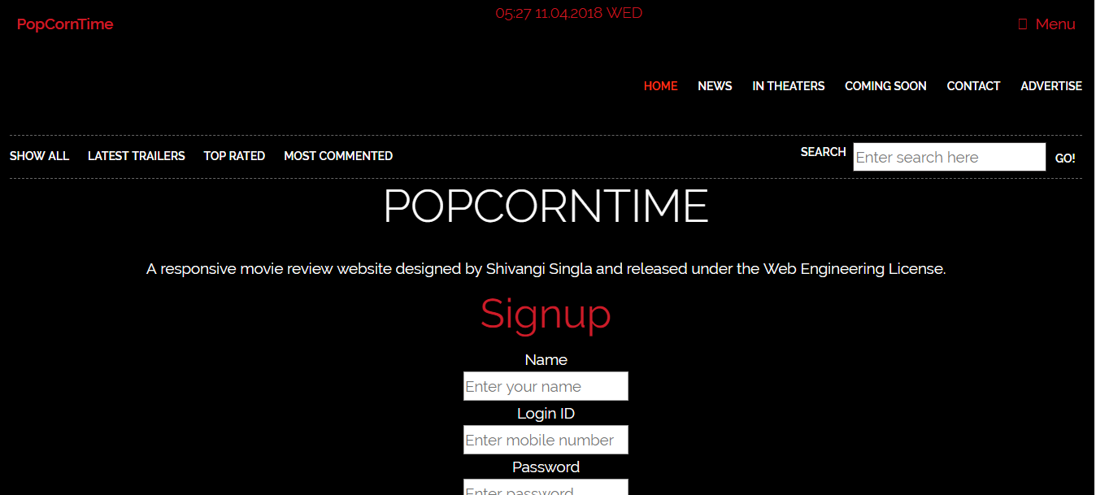

EXPERIMENT 6
AIM: To use Java Server Pages (JSP) to make backend of website. Use a form to enter data and do form validation.

Source Code:
index:

<!DOCTYPE HTML>
<%@ page import = "java.io.*,java.util.*, javax.servlet.*,java.text.*" %>
<html>
<head>
<title>PopCornTime</title>
<meta charset="utf-8" />
<style type="text/css">
#menu { float:right; clear:right; padding-top:29px; padding-bottom:47px; }
#menu ul { list-style:none; }
#menu ul li { float:left; display:inline; padding-left:25px; }
#menu ul li a { font-size:14px; font-weight:bold; color:#ffffff; text-decoration:none; }
#menu ul li a.active,
#menu ul li a:hover { color:#ff361a; }
#sub-navigation { display:block; clear:right; border-top:1px dashed #666; border-bottom:1px dashed #666; padding:8px 0; }
#sub-navigation ul { list-style:none; }
#sub-navigation ul li { float:left; display:inline; padding-right:23px; }
#sub-navigation ul li a { font-size:14px; font-weight:bold; color:#ffffff; line-height:24px; text-decoration:none; }
#sub-navigation ul li a:hover { text-decoration:underline; }
#search { width:346px; margin:0 0 0 auto; }
#search label { float:left; display:inline; font-size:14px; font-weight:bold; color:#ffffff; line-height:24px; padding-right:6px; }
#search .search-field { width:238px; border: 1px solid #413e3e; background:#ffffff; color:#787878; padding:2px 0 2px 2px; }
#search .search-button { font-size:14px; font-weight:bold; border:0; background:none; color:#ffffff; cursor:pointer; }
</style>
<link rel="stylesheet" href="main1.css" />
</head>
<body class="is-preload">
<!-- Header -->
<header id="header">
<a class="logo" href="first.html">PopCornTime</a>
<%
Date date = new Date();
SimpleDateFormat ft = new SimpleDateFormat ("hh:mm dd.MM.yyyy E");
out.print( "<h2 align = \"right\">" +ft.format(date)+"</h2>");
%>
<nav>
<a href="#menu">Menu</a>
</nav>
</header>
<!-- Main -->
<div id="menu">
<ul>
<li><a class="active" href="#">HOME</a></li>
<li><a href="#">NEWS</a></li>
<li><a href="#">IN THEATERS</a></li>
<li><a href="#">COMING SOON</a></li>
<li><a href="#">CONTACT</a></li>
<li><a href="#">ADVERTISE</a></li>
</ul>
</div>
<div id="sub-navigation">
<ul>
<li><a href="#">SHOW ALL</a></li>
<li><a href="#">LATEST TRAILERS</a></li>
<li><a href="#">TOP RATED</a></li>
<li><a href="#">MOST COMMENTED</a></li>
</ul>
<div id="search">
<form action="home_submit" method="get" accept-charset="utf-8">
<label for="search-field">SEARCH</label>
<input type="text" name="search field" value="Enter search here" id="search-field" title="Enter search here" class="blink search-field" />
<input type="submit" value="GO!" class="search-button" />
</form>
</div>
</div>
<section id="banner">
<div class="inner">
<h1>PopCornTime</h1>
<p>A responsive movie review website
designed by Shivangi Singla and released under the Web Engineering License.</p>
</div>
<div class="signup1">
<form class="signup1-form validate-form" name="form1" action="welcome.jsp" onsubmit="return validate()">
<span class="signup1-form-title">
Signup
</span>
<div class="name-input" >
Name<br>
<input class="input100" type="text" name="name" placeholder="Enter your name" required>
</div>
<div class="mobile-input" >
Login Id<br>
<input class="input100" type="text" name="mobile" placeholder="Enter 10 digit mobile number" required onkeypress="validmob(event)" >
</div>
<div class="pswd-input" >
Password<br>
<input class="input100" type="password" name="pswd" placeholder="Enter password" required>
</div>
<div class="rpswd-input" >
Retype Password<br>
<input class="input100" type="password" name="rpswd" placeholder="Retype your password" required>
</div>
<div class="signup1-form-btn">
<button class="cancel-btn" type="reset">
<span>
Cancel
</span>
</button>
<button class="next-btn" value="go">
<span>
Next
</span>
</button>
</div>
</form>
</div>
</section>
<%
out.println("Your IP address is " + request.getRemoteAddr());
%>
<script language="javascript" type="text/javascript">
function validmob(evt){
var theEvent = evt || window.event;
if (evt.key == "Backspace" || evt.key == "Del") return true;
var key = theEvent.keyCode || theEvent.which;
key = String.fromCharCode( key );
var regex = /[0-9]|\./;
if(!regex.test(key) ) {
theEvent.returnValue = false;
if(theEvent.preventDefault) theEvent.preventDefault();
}}
function validate(){
var name = document.forms["form1"]["name"].value;
var pswd = document.forms["form1"]["pswd"].value;
var rpswd = document.forms["form1"]["rpswd"].value;
var mobile = document.forms["form1"]["mobile"].value;
var re = /^(?=.*\d)(?=.*[a-z])(?=.*[A-Z]).{8,}$/
var n = /^(?=.*[a-z])(?=.*[A-Z])$/
if(name.length<8)
{alert(name+": Name must contain atleast 8 characters");
return false;}
if(mobile.length!=10)
{alert(mobile+": Mobile entered is incorrect");
return false;}
if(!re.test(pswd)) {
alert("Error: password must contain at least one uppercase letter (A-Z),one uppercase letter (a-z),one number(0-9) and must have at least 8 characters!");
return false;}
if(pswd != rpswd)
{alert("Password don't match");
return false;}
}
</script>
<!-- Footer -->
<footer id="footer">
<div class="inner">
<div class="content">
<section>
<h2>PopCornTime</h2>
<p>PopCornTime, the world's most popular and authoritative source for movie, TV, and celebrity content.<br> Read critic and user reviews.<br> Explore popular Hollywood and Indian movies and TV shows, entertainment news, and the latest awards and events.<br> Track what you want to watch on your Watchlist, and rate movies and TV shows you've seen.
</p>
</section>
<section>
<h4>Company</h4>
<ul class="alt">
<li><a href="#">About Us</a></li>
<li><a href="#">Copyright</a></li>
<li><a href="#">Privacy.</a></li>
</ul>
</section>
<section>
<h4>Contact Us</h4>
<ul class="plain">
<li><a href="#"><i class="icon fa-twitter">&nbsp;</i>Twitter</a></li>
<li><a href="#"><i class="icon fa-facebook">&nbsp;</i>Facebook</a></li>
</ul>
</section>
</div>
</div>
</footer>
<script src="assets/js/jquery.min.js"></script>
<script src="assets/js/browser.min.js"></script>
<script src="assets/js/breakpoints.min.js"></script>
<script src="assets/js/util.js"></script>
<script src="assets/js/main.js"></script>
</body>
</html>

